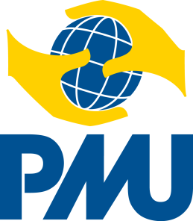
Annex 6.15 Concept Note for a development intervention
using PMU’s own funds up to SEK 150,000

Signed and scanned concept note is sent via e-mail to PMU: egnamedel@pmu.se

Choose an alternative and tick the appropriate box

Minor Grant – Development Intervention |  | Spero Intervention
 |  | Use instead: 4.1 b Concept Note Hum PMU funds up to 150,000 SEK
Children’s Rights Intervention |  | Minor Grant – Humanitarian Intervention

- Preliminary name of the intervention:

- Amount applied for in SEK:

- The intervention will take place in (country/area):

- Proposed period for the intervention:

- Summary of the intervention, including goals/expected results of the intervention and the planned main activities to achieve these: (max 150 words)

- Preliminary target group:

- Local partner for the implementation of the planned activities:

- Signatures of Swedish and local partner:

................................................... .......................................................
Place and date Place and date

................................................... ......................................................
Signature Signature

................................................... ......................................................
Position within Swedish partner Position within local partner

